PROJECT REPORT

College and Hostel Integrated Management System

1. Introduction

1.1 Project Overview
The College and Hostel Integrated Management System (CHIMS) is a backend web application designed to digitize and unify the administrative operations of an academic institution and its affiliated hostel. The system consolidates academic records (students, teachers, courses, departments) with hostel operations (room allocation and maintenance complaints) into a single, coherent data model and API surface.
The project is implemented as a RESTful service using Java with the Spring Boot framework, backed by MongoDB as the persistence layer. It exposes a comprehensive set of HTTP endpoints that can be consumed by any frontend (web or mobile) or tested directly through the built-in Swagger/OpenAPI documentation interface.

1.2 Objectives
- To design a unified data model that connects academic entities (Department, Course, Teacher, Student) with hostel entities (Room, Complaint).
- To provide complete CRUD (Create, Read, Update, Delete) operations for every core entity through a RESTful API.
- To automate hostel room allocation based on real-time room capacity and occupancy.
- To implement an intelligent complaint-management workflow that automatically classifies complaints by priority.
- To provide aggregated analytics and a summary dashboard for administrative decision-making.
- To enforce data integrity through server-side validation and centralized exception handling.
- To document the API formally using the OpenAPI (Swagger) specification.

2. Technology Stack
Layer | Technology Used
Programming Language | Java 21
Application Framework | Spring Boot 4.1.0 (Spring Web MVC)
Database | MongoDB (NoSQL, document-oriented) via Spring Data MongoDB
Build Tool | Apache Maven (with Maven Wrapper)
API Documentation | springdoc-openapi (Swagger UI) v2.8.9
Validation | Spring Boot Starter Validation (Jakarta Bean Validation)
Boilerplate Reduction | Project Lombok
IDE / Environment | Eclipse-based project structure (.project, .classpath)
Testing | Spring Boot Test, Spring Data MongoDB Test

3. Domain Model
The system is built around six core MongoDB document collections. Relationships between documents are modelled using reference fields (storing the ObjectId of a related document as a String) rather than embedding, which keeps each collection independently queryable and scalable.

3.1 Entities and Fields

3.1.1 Department
Field | Type | Constraints / Notes
id | String | MongoDB-generated primary key
departmentName | String | Required (@NotBlank)

3.1.2 Course
Field | Type | Constraints / Notes
id | String | Primary key
courseName | String | Required (@NotBlank)
departmentId | String | Reference to a Department

3.1.3 Teacher
Field | Type | Constraints / Notes
id | String | Primary key
name | String | Required (@NotBlank)
departmentId | String | Reference to a Department

3.1.4 Student
Field | Type | Constraints / Notes
id | String | Primary key
name | String | Required (@NotBlank)
email | String | Required; must be a valid email format (@Email)
courseId | String | Reference to a Course
roomId | String | Reference to a Room

3.1.5 Room
Field | Type | Constraints / Notes
id | String | Primary key
roomNo | String | Required (@NotBlank)
capacity | Integer | Required; minimum value of 1 (@NotNull, @Min(1))

3.1.6 Complaint
Field | Type | Constraints / Notes
id | String | Primary key
title | String | Required (@NotBlank)
description | String | Optional details about the complaint
studentId | String | Required; reference to the reporting Student
status | String | Defaults to “Incomplete”; later set to “Completed”
priority | String | Auto-assigned: “High Priority” or “Low Priority”

3.2 Relationship Summary
- A Department has many Courses and many Teachers (one-to-many).
- A Course belongs to one Department and has many Students (one-to-many).
- A Teacher belongs to one Department (many-to-one).
- A Student belongs to one Course and is allocated to one Room (many-to-one each).
- A Room can house many Students, up to its defined capacity (one-to-many, capacity-constrained).
- A Complaint is filed by one Student; a Student may file many Complaints (one-to-many).

4. Business Logic

4.1 Capacity-Aware Student Admission
When a new student is added via POST /students, the system first verifies that the referenced room exists and is not already at full capacity. If the room is full or does not exist, the request is rejected with a descriptive message rather than silently over-allocating a room.
Eg. Inserting a student in a room that is at full capacity.

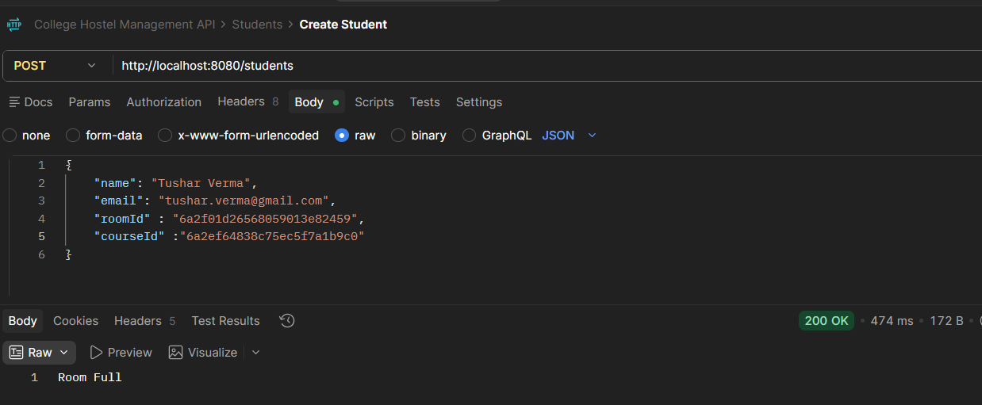

4.2 Automatic Room Allocation
The POST /students/room-allocate endpoint removes the need to manually choose a room. It scans all existing rooms for the first one with available capacity and assigns the student there. If every existing room is full, the system automatically creates a new room (with a generated room number and a default capacity of 3) and assigns the student to it — ensuring no admission is ever blocked by a lack of space.
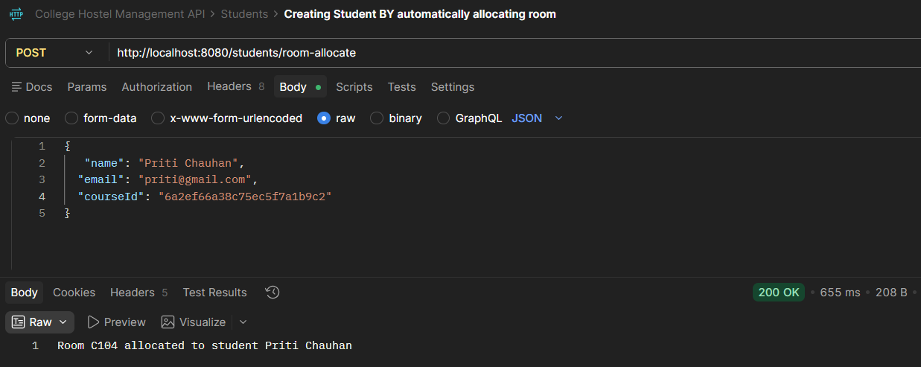

4.3 Automatic Complaint Prioritization
When a complaint is submitted via POST /complaints, its title is scanned (case-insensitively) for keywords associated with urgent safety issues — including “fire”, “circuit”, “electric”, “leakage”, and “security”. If any of these keywords are present, the complaint is automatically flagged as High Priority; otherwise, it is marked Low Priority. Every new complaint also defaults to a “Incomplete” status, with a dedicated endpoint (PUT /complaints/{id}/complete) to mark it completed.
Eg. New complaint defaulting to “Incomplete”
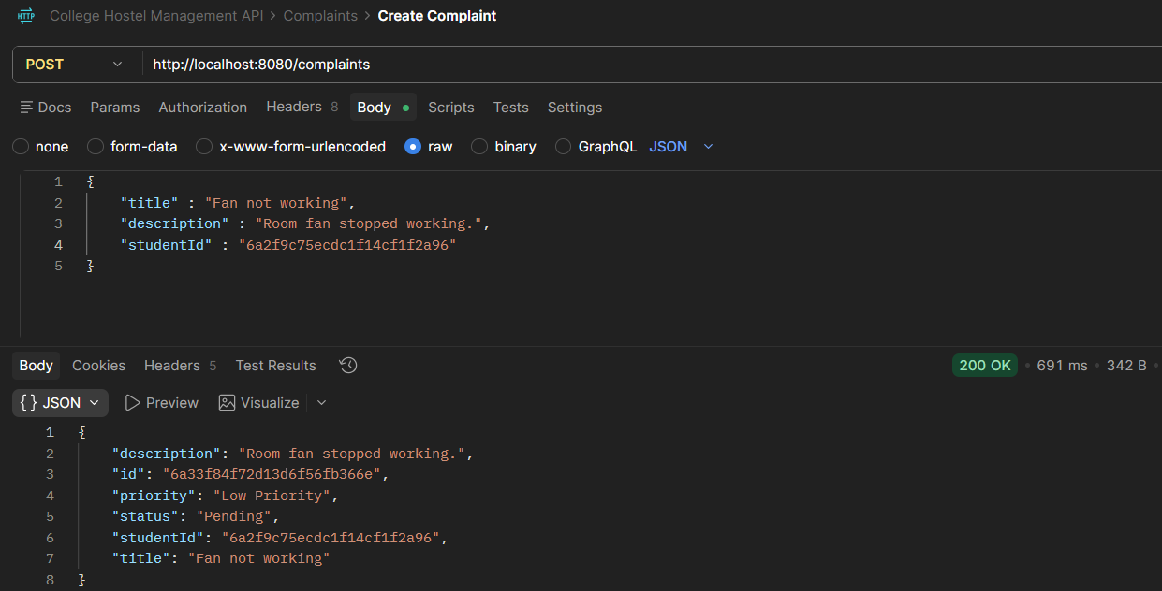

4.4 Centralized Validation and Error Handling
All entity creation requests are validated using Jakarta Bean Validation annotations (@NotBlank, @NotNull, @Min, @Email). Validation failures are caught globally by GlobalExceptionHandler and converted into a field-by-field map of error messages. Runtime exceptions — such as looking up a non-existent ID — are similarly caught and returned as a structured JSON error object, rather than a raw server stack trace.
Eg, Error being directly conveyed in Postman
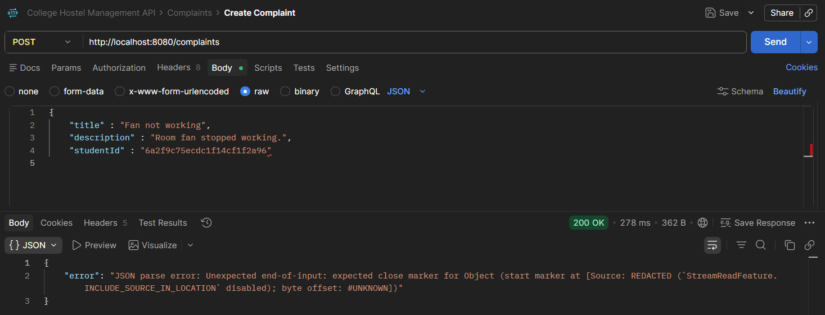

4.5 Aggregated Analytics
The AnalyticsController uses MongoDB's native aggregation framework (via MongoTemplate) to compute grouped statistics directly inside the database — including the number of students per course, students per room, teachers per department, and complaints grouped by status or priority — before enriching the raw results with human-readable names (e.g., course name instead of course ID).
Eg. Showing complaints by priority
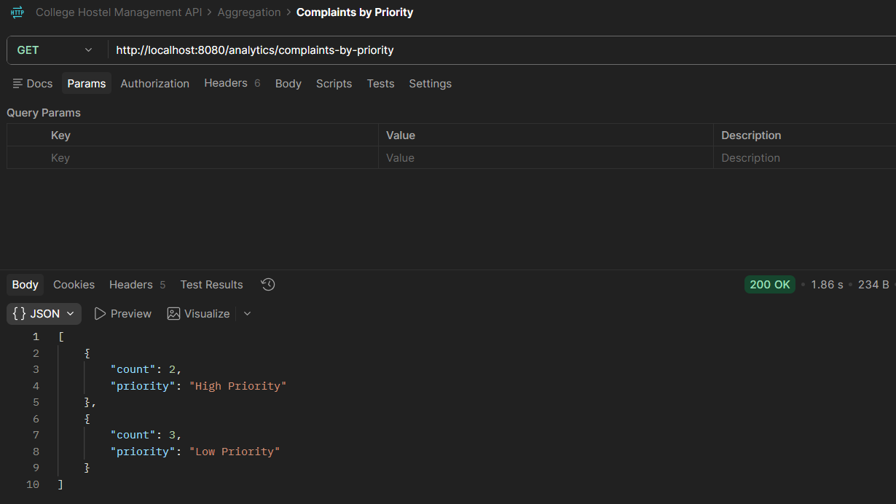

5. REST API Reference
All endpoints return and accept JSON. Below is the complete list of exposed endpoints, grouped by resource. The API is also explorable interactively through Swagger UI at runtime.

5.1 Student APIs — /students
Method | Endpoint | Description
POST | /students | Create a new student (validates room existence and capacity)
POST | /students/room-allocate | Create a student and automatically allocate an available room (creates a new room if needed)
GET | /students | Retrieve all students
GET | /students/{id} | Retrieve a single student by ID
PUT | /students/{id} | Update a student's name, email, course, or room
DELETE | /students/{id} | Delete a student by ID
GET | /students/{studentId}/complaints | Retrieve all complaints filed by a specific student

5.2 Teacher APIs — /teachers
Method | Endpoint | Description
POST | /teachers | Create a new teacher
GET | /teachers | Retrieve all teachers
GET | /teachers/{id} | Retrieve a single teacher by ID
PUT | /teachers/{id} | Update a teacher's name or department
DELETE | /teachers/{id} | Delete a teacher by ID

5.3 Course APIs — /courses
Method | Endpoint | Description
POST | /courses | Create a new course
GET | /courses | Retrieve all courses
GET | /courses/{id} | Retrieve a single course by ID
PUT | /courses/{id} | Update a course's name or department
DELETE | /courses/{id} | Delete a course by ID
GET | /courses/{courseId}/students | Retrieve all students enrolled in a specific course

5.4 Department APIs — /departments
Method | Endpoint | Description
POST | /departments | Create a new department
GET | /departments | Retrieve all departments
GET | /departments/{id} | Retrieve a single department by ID
PUT | /departments/{id} | Update a department's name
DELETE | /departments/{id} | Delete a department by ID
GET | /departments/{departmentId}/courses | Retrieve all courses under a department
GET | /departments/{departmentId}/teachers | Retrieve all teachers under a department

5.5 Room APIs — /rooms
Method | Endpoint | Description
POST | /rooms | Create a new hostel room
GET | /rooms | Retrieve all rooms
GET | /rooms/{id} | Retrieve a single room by ID
PUT | /rooms/{id} | Update a room's number or capacity
DELETE | /rooms/{id} | Delete a room by ID
GET | /rooms/{roomId}/students | Retrieve all students currently allocated to a room

5.6 Complaint APIs — /complaints
Method | Endpoint | Description
POST | /complaints | File a new complaint (auto-sets status to Incomplete and priority by keyword scan)
GET | /complaints | Retrieve all complaints
GET | /complaints/highpriority | Retrieve all High Priority complaints
GET | /complaints/lowpriority | Retrieve all Low Priority complaints
GET | /complaints/{id} | Retrieve a single complaint by ID
PUT | /complaints/{id} | Update a complaint's title, description, student, or status
PUT | /complaints/{id}/complete | Mark a complaint's status as Completed
DELETE | /complaints/{id} | Delete a complaint by ID

5.7 Analytics APIs — /analytics
Method | Endpoint | Description
GET | /analytics/students-per-course | Count of students grouped by course, enriched with course name
GET | /analytics/students-per-room | Count of students grouped by room, enriched with room number
GET | /analytics/teachers-per-department | Count of teachers grouped by department, enriched with department name
GET | /analytics/complaints-by-status | Count of complaints grouped by status
GET | /analytics/complaints-by-priority | Count of complaints grouped by priority
GET | /analytics/room-occupancy | Per-room breakdown of capacity, occupied seats, and available seats

5.8 Dashboard API — /dashboard
Method | Endpoint | Description
GET | /dashboard | Returns institution-wide totals: students, teachers, courses, departments, and rooms

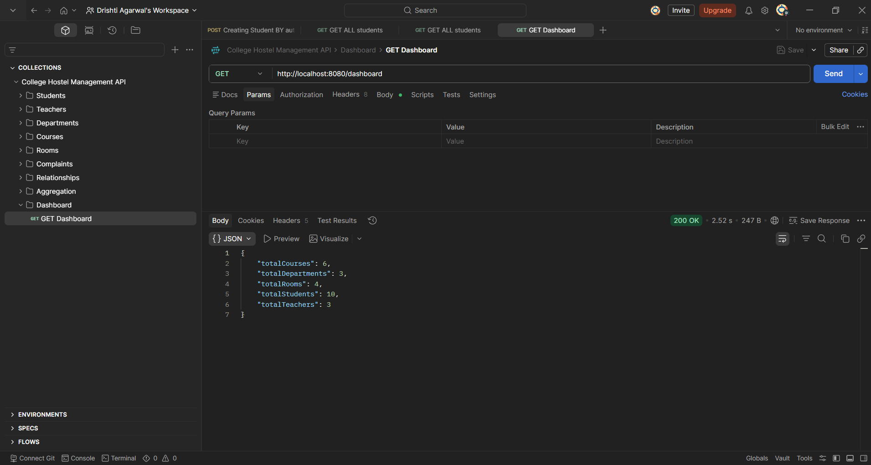

6. Sample API Interaction

6.1 Creating a Student (Auto Room Allocation)
Request: POST /students/room-allocate
{
"name": "Ananya Sharma",
"email": "ananya.sharma@example.edu",
"courseId": "665fa1e2c2a4b53f8e9d10a1"
}
Response (200 OK):
"New Room A103 allocated to student Ananya Sharma"

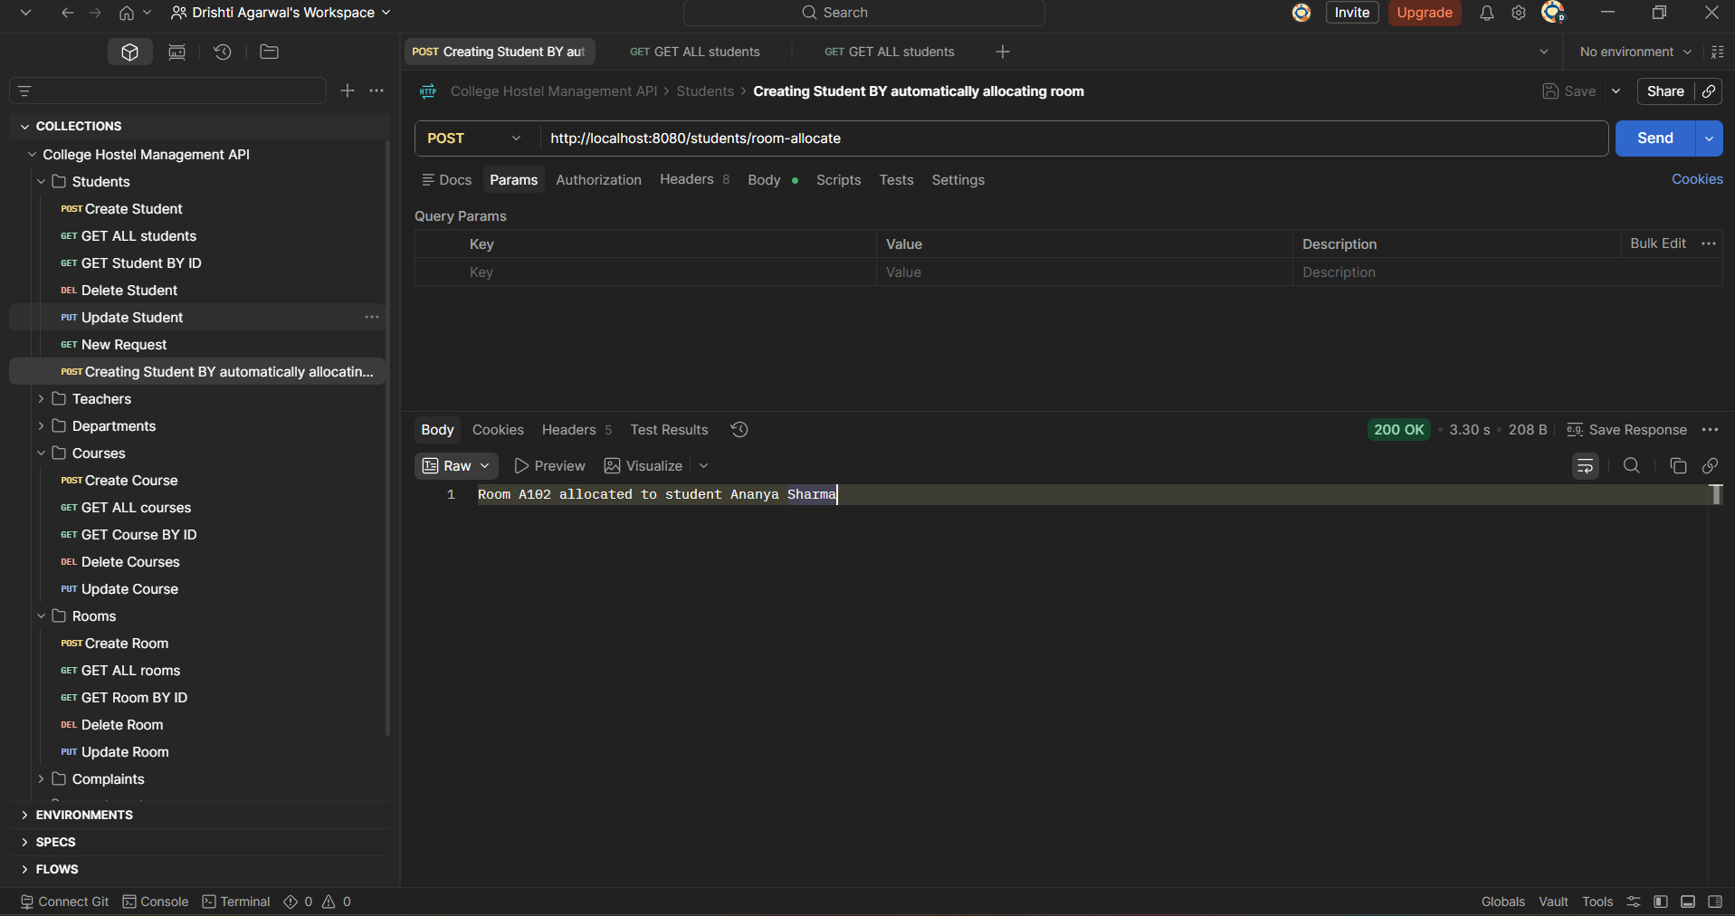

6.2 Filing a Complaint
Request: POST /complaints
{
"title": "Electric wiring fault in Room B12",
"description": "Sparking noticed near the switchboard",
"studentId": "665fa1e2c2a4b53f8e9d10a1"
}
Response (200 OK):
{
"id": "665fa201c2a4b53f8e9d10b7",
"title": "Electric wiring fault in Room B12",
"description": "Sparking noticed near the switchboard",
"studentId": "665fa1e2c2a4b53f8e9d10a1",
"status": "Incomplete",
"priority": "High Priority"
}
Note: the system automatically assigned High Priority because the complaint title contained the keyword “electric”.

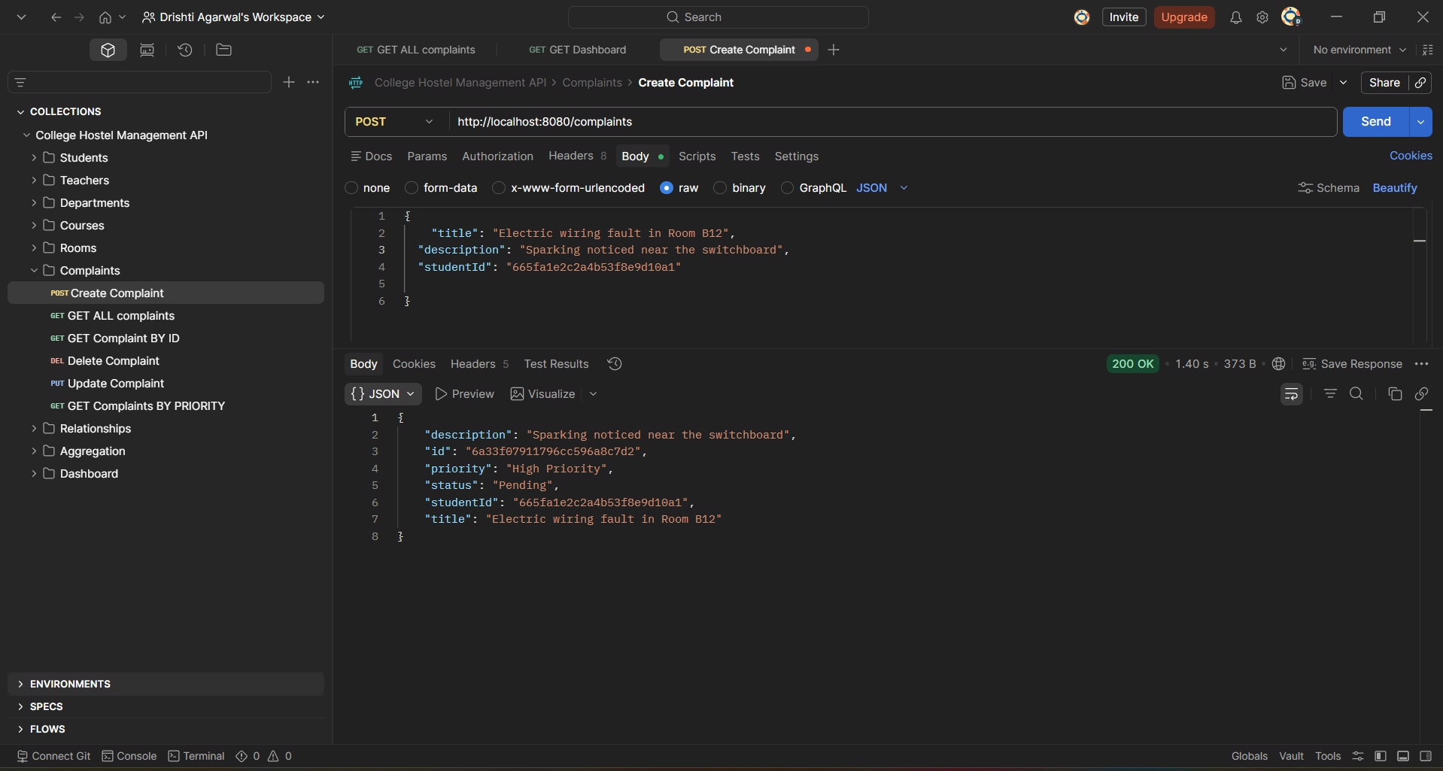

7. API Documentation (Swagger UI)
The project integrates springdoc-openapi to auto-generate interactive API documentation directly from the controller annotations (@Tag, @Operation). When the application is running, the documentation is accessible through a browser, allowing every endpoint to be inspected and tested without external tools such as Postman.

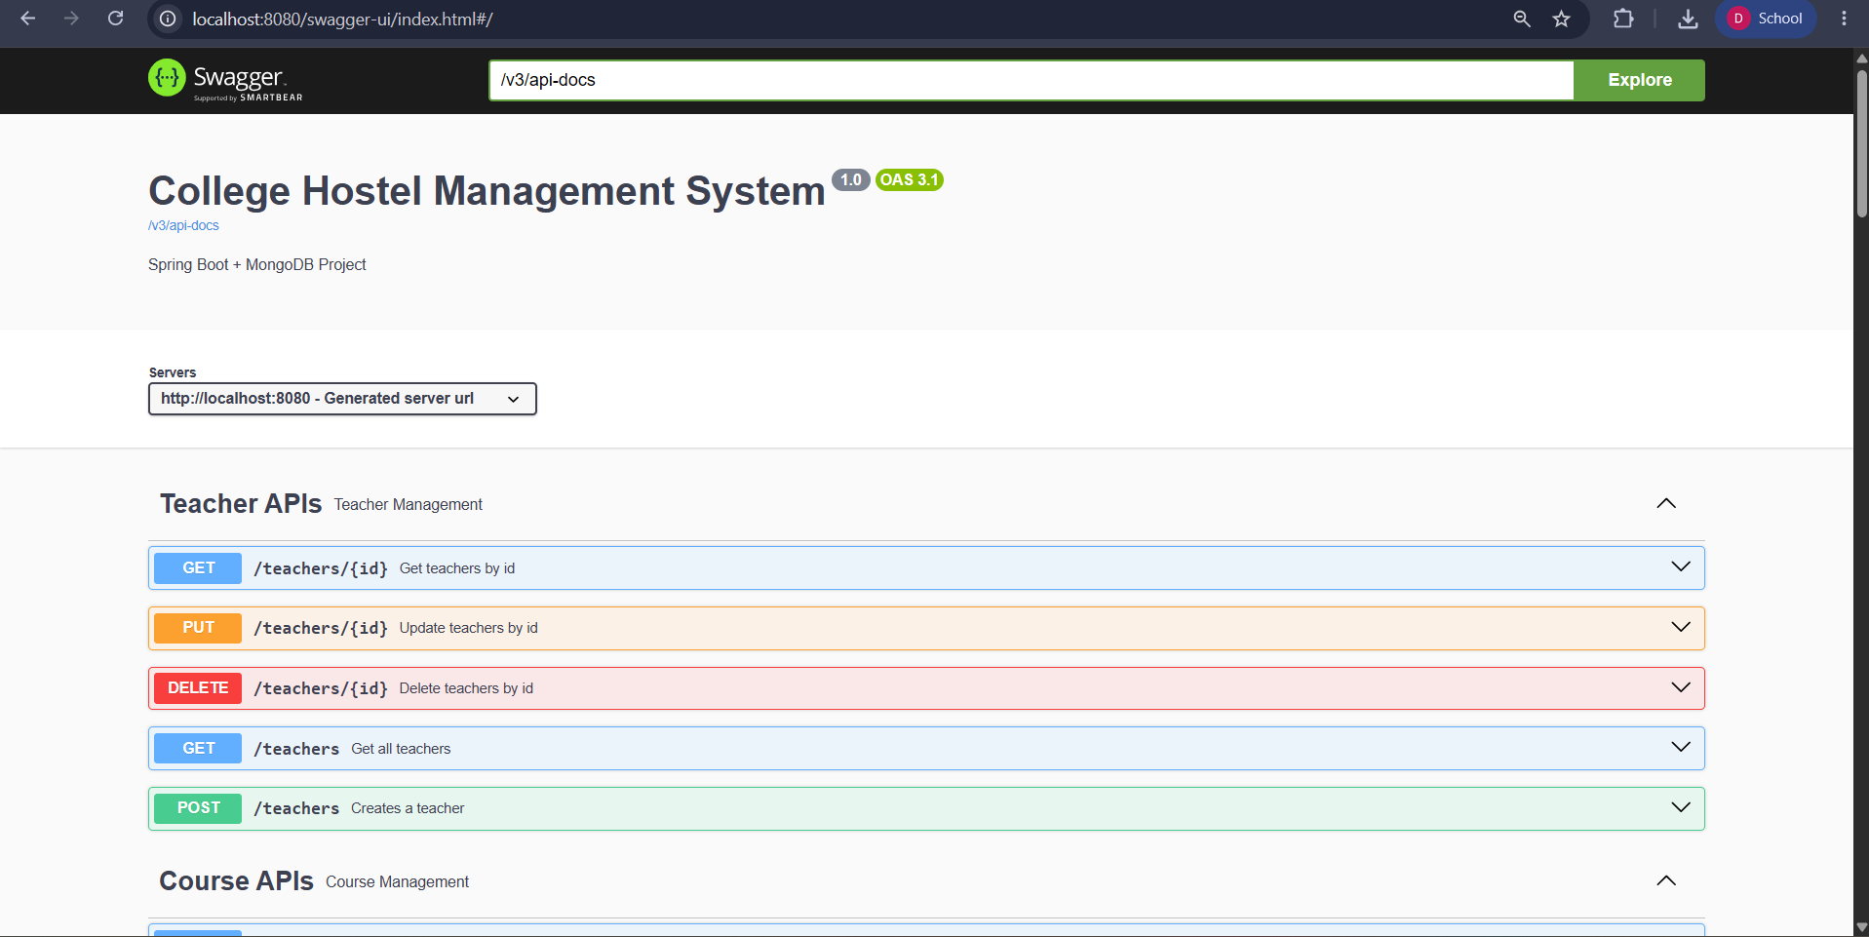
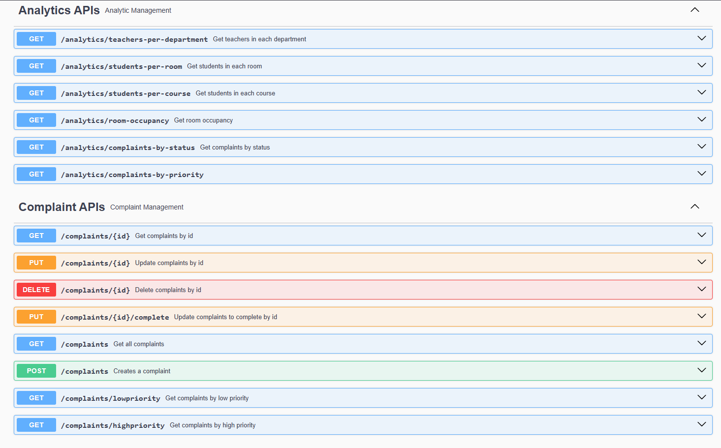
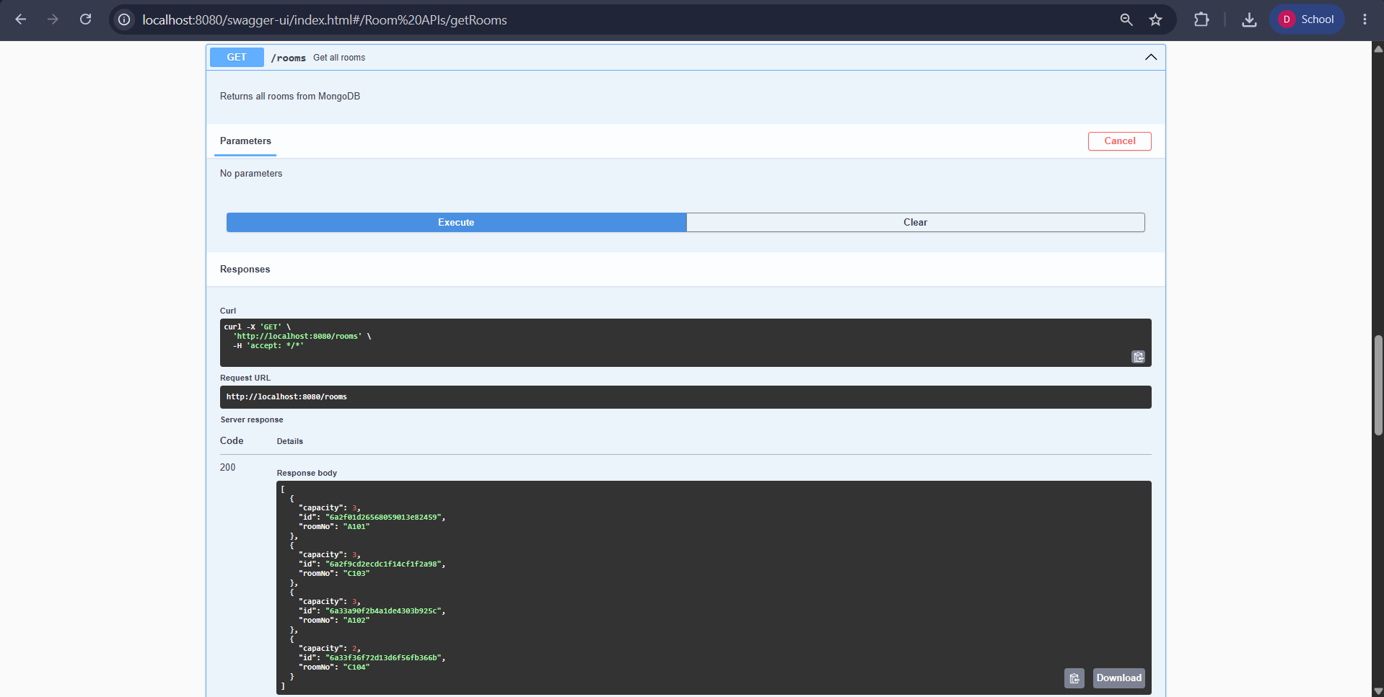

8. Testing
The project includes a Spring Boot test scaffold (CollegeHostelIntegratedApplicationTests) along with the spring-boot-starter-data-mongodb-test and spring-boot-starter-webmvc-test dependencies, which provide the foundation for context-loading tests, repository-level tests against an embedded/test MongoDB instance, and MockMvc-based controller tests.

8.1 Manual Testing via Swagger / Postman
During development, endpoints were exercised manually to verify expected behavior, including: successful and rejected student creation (room full / room not found), automatic room creation when all rooms are full, correct priority classification for complaints containing safety-related keywords, and accurate aggregation results from the analytics endpoints.
Eg. Testing room occupancy
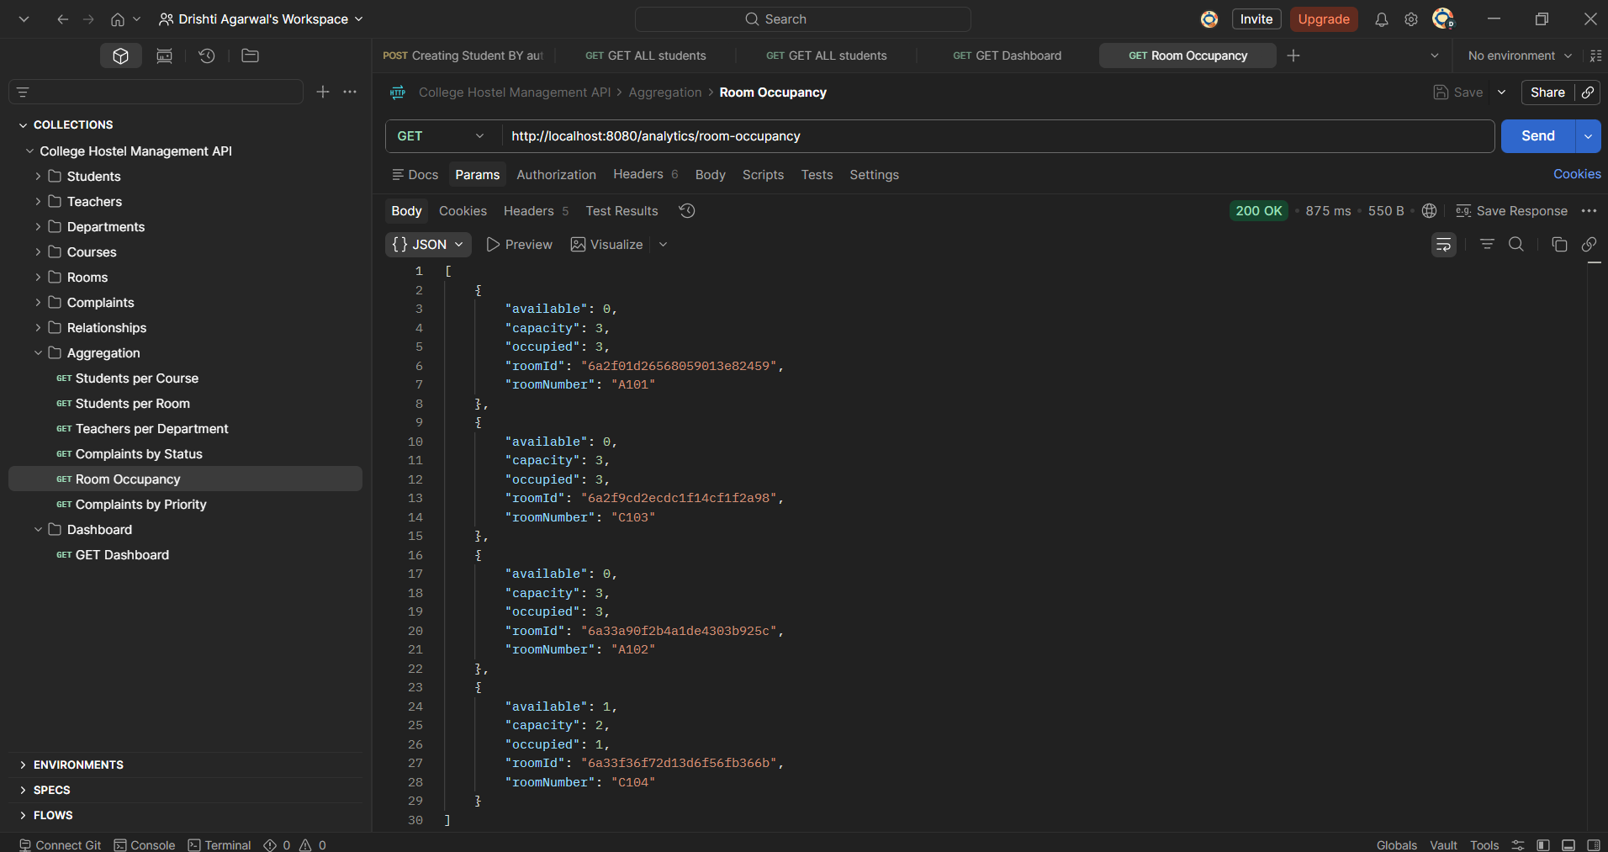

9. Project Structure
college-hostel-integrated/
├── src/main/java/com/college/college_hostel_integrated/
│ ├── CollegeHostelIntegratedApplication.java
│ ├── config/
│ │ └── SwaggerConfig.java
│ ├── controller/
│ │ ├── StudentController.java
│ │ ├── TeacherController.java
│ │ ├── CourseController.java
│ │ ├── DepartmentController.java
│ │ ├── RoomController.java
│ │ ├── ComplaintController.java
│ │ ├── AnalyticsController.java
│ │ ├── dashboardController.java
│ │ └── *RelationshipController.java
│ ├── model/
│ │ ├── Student.java, Teacher.java, Course.java,
│ │ └── Department.java, Room.java, Complaint.java
│ ├── repository/
│ │ └── (MongoRepository interfaces per entity)
│ ├── dto/
│ │ └── (Dashboard.java, RoomOccupancy.java, ...)
│ └── exception/
│ └── GlobalExceptionHandler.java
├── src/main/resources/
│ └── application.properties
├── src/test/java/...
│ └── CollegeHostelIntegratedApplicationTests.java
└── pom.xml

